VE Day and World War 2 Activities – Year 3 and Year 4
These activities provide opportunities for you to learn more about VE Day and World War 2.
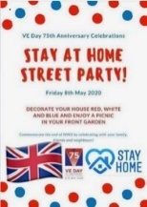  ‘Stay At Home’ Street Party  Read this article on Newsround and look closely at the photographs. How did people celebrate in 1945? Plan your own ‘stay at home’ party.  What games could be played? What decorations would be put up? What food would be eaten? Who would be there?  For something more simple, you could design your own VE Day party invitation to encourage your neighbours to join in with their stay at home party, or create your own Union Jack flag bunting or make a Union Jack flag out of Lego! | Understanding World War Two/VE Day  On 8th May 1945, Britain celebrated the end of World War Two. To understand why VE Day was so important, you need to understand WW2. Visit these sites to help in your research:  Primary Homework Help - WW2  A Brief Overview of World War II – Video  BBC Teach - VE Day  Can you create a timeline of important events leading up to VE Day? | Wartime Recipes  With one rationed egg and a packet of powdered milk in the larder, World War II’s home cooks had to be creative. Find out what families were eating over 75 years ago.  Create some delicious meals using the recipe booklets below. You could serve them at your ‘Stay at Home Party!’  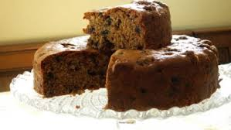  Wartime Ration Recipes  WW2 Cake  Wartime Scones  Jam Tarts
Crack The Codes  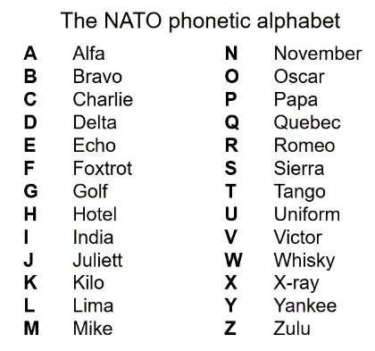  Phonetic Alphabet  The phonetic alphabet that was used in RAF transmissions during the war. Learn to spell your name using the phonetic alphabet e.g.  Ted = Tango Echo Delta  Morse Code  Morse code is a communication system that represents the alphabet and numbers with a series of dots, dashes or a combination of both as shown here. Watch this video to find out more about Morse Code.  Can you write a secret coded message for your family to crack? |   VE Day Songs  Try and learn the Horrible Histories VE Day song and perform it to your family.  Create your own motivational song. Listen to some of the following clips for inspiration. Click below to listen to some more traditional war time songs as well as the links below.  Wartime song lyrics  Long way to Tipperary/ Pack up your troubles  We’ll meet again  The White Cliffs of Dover  Learn step-by-step how to Swing dance (The Lindy Hop) which originated in the late 1920s and early 1930s in Harlem, New York City. | 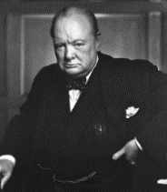  Winston Churchill  Who was Winston Churchill? Why do we remember him today? Produce a fact file/ poster displaying your information.  Create a mind map or list of facts about Winston Churchill.  What was his job?  Why was he so important during WW2?  What was one of his famous phrases?  Can you describe his characteristics?  Why he was important?  You can read more about Churchill using these links from Ducksters. You may present this information in any way you choose.  CHALLENGE: Can you learn Winston Churchill’s Victory speech and record yourself presenting it?
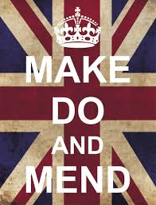  Make, Do and Mend  During WW2, there was a shortage of materials to make clothes. People were urged to "Make, do and mend".  Do you have any clothes or accessories that you could ‘upcycle’ into new clothing or something completely different to give it another purpose and a new lease of life? | Europe during the Second World War  Colour in the countries on a map of Europe according to whether they were Allies, Axis, Axis controlled or Neutral.  NatGeo Kids - WW2 History | 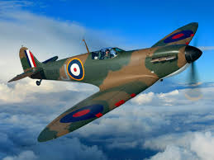  Spitfire Science  Design and make your own Spitfire. You could make it out of paper, wood, recycled materials, etc. Test out your design. How far does it glide?  Does the material used for a paper plane affect the distance it travels? Try using newspaper, card, tinfoil, etc and carry out a test. Remember, only change ONE thing to make it a fair test.

